VISTAAR FINANCIAL SERVICES PRIVATE LIMITED
RCU VERIFICATION REPORT
(SKYLINE RISK AUDIT SERVICES)
STATE | TN-E
BRANCH | SULUR
LOAN ACCOUN TNUMBER | 00000500SBML00000255 / DB202609032532394
PRODUCT | SARAL
APPLICANT NAME | ASWATH D
CO-APPLICANT NAME | PUSHPA D
LOAN AMOUNT | 1000000
SAMPLED DOCUMENTS | RV AND BV
PICKUP CRITERIA | TRIGGER
SAMPLED DATE | 9/4/2026
REPORT DATE | 9/6/2026
TAT | 1
DISBURSEMENT TYPE | PRE

AGENCY DEDUPE STATUS REMARKS | NO ADVICER FOUND
VISITEDRESIDENCE ADDRESS | 62 JKJ COLONY BHARTHIPURAM PALLADAM MANICKAPURAM MANI TIRUPPUR 641664
NEIGHBOUR/THIRD PARTY CHECK /
REFERENCE REMARKS | NA
FOR RESIDENCE ADDRESS
RESIDENCE ADDRESS VERIFICATION REMARKS | RESIDENCE ADDRESS VERIFICATION : STATUS : NEGATIVE  Duirng the visit, the given residence location; The residence was not traceable at the address provided. Upon contacting the applicant, he was confirmed that they shifted the given address and he not cooperative for the verification properly. So we are unable to verify the given details. So we mark it as Negative.
VISITED BUSINESS ADDRESS | SIVANMALAI & CO MANICKAPURAM ROAD VAIRAM NAGAR PALLADAM TIRUPPUR Tamil Nadu 641664
NEIGHBOUR / THIRD PARTY CHECK / REFERENCE REMARKS FOR BUSINESS ADDRESS | NA
BUSINESS ADDRESS VERIFICATION REMARKS | BUSINRSS ADDRESS VERIFICATION : STATUS : NEGATIVE  Duirng the visit, the given business location; The business was not traceable at the address provided. Upon contacting the applicant, he was not cooperative for the verification properly. So we are unable to verify the given details. So we mark it as Negative.
DOCUMENTS VERIFICATION CHECK REMARKS | NA
TRC/ANYOTHER CHECKS REMARKS | NA
RCU VERIFICATION STATUS | NEGATIVE
LANDMARK PHOTOS

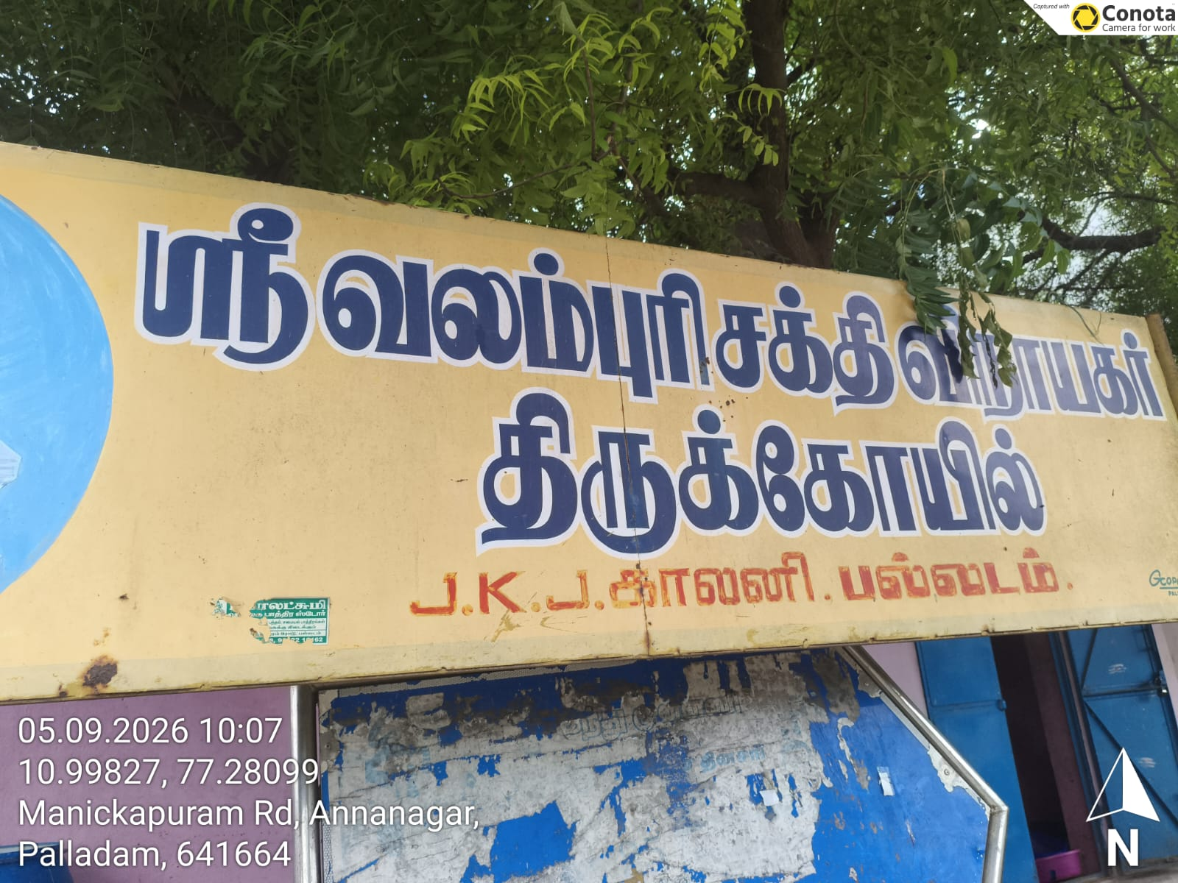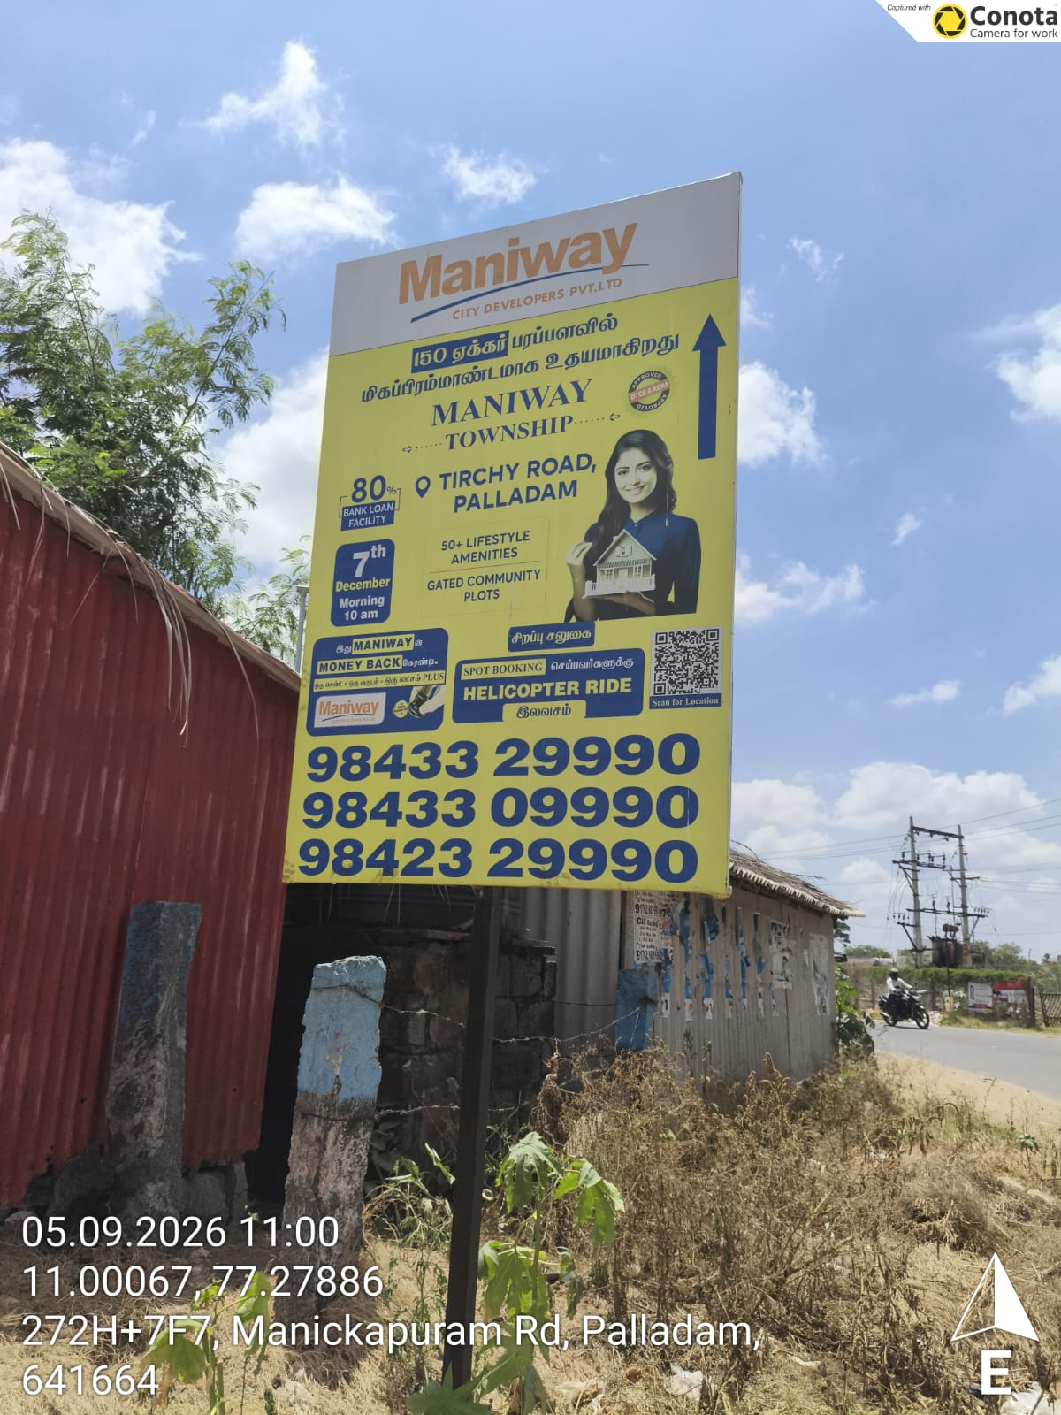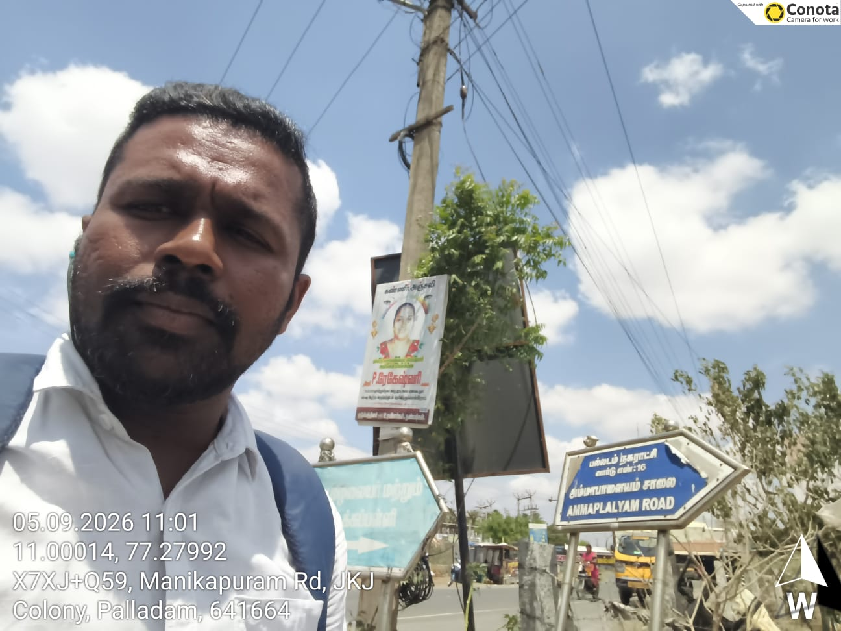

NAME OF VERIFIER: ADHARSHA

SIGNATURE & SEAL THE AGENCY

